DHARSHNA U 231901008

WORKING WITH CONSTRAINTS

EXPERIMENT:4

DATE:14-08-2024

Find the Solution for the following:

1. Add a table-level PRIMARY KEY constraint to the EMP table on the ID column.The constraint should be named at creation. Name the constraint my_emp_id_pk.

CREATE TABLE EMP2 (

ID NUMBER(7),

LAST_NAME VARCHAR2(25) NOT NULL,

FIRST_NAME VARCHAR2(25) NOT NULL,

CONSTRAINT my_emp_id_pk PRIMARY KEY (ID));

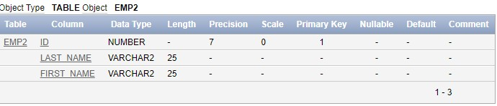

1. Create a PRIMAY KEY constraint to the DEPT table using the ID column. The constraint should be named at creation. Name the constraint my_dept_id_pk.

CREATE TABLE DEPT2(

ID NUMBER(7) NOT NULL,

DEPT_NAME VARCHAR2(50),

CONSTRAINT my_dept_id_pk PRIMARY KEY (ID));

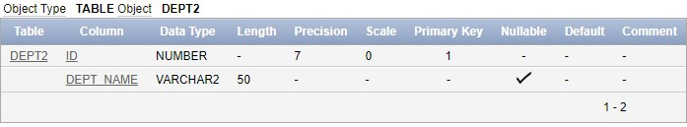

CSE(CYBER SECURITY)-2nd YEAR

PRIYANGA M 231901037

1. Add a column DEPT_ID to the EMP table. Add a foreign key reference on the EMP table that ensures that the employee is not assigned to nonexistent deparment. Name the constraint

my_emp_dept_id_fk.

ALTER TABLE EMP2

ADD DEPT_ID NUMBER(7);

ALTER TABLE

ADD CONSTRAINT my_emp_dept_id_fk FOREIGN KEY (DEPT_ID)

REFERENCES DEPT2(ID);

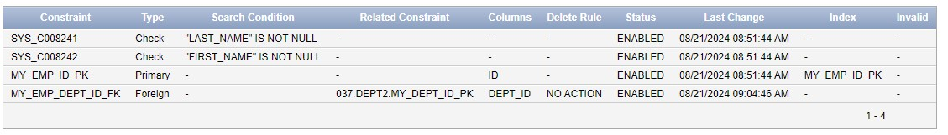

1. Modify the EMP table. Add a COMMISSION column of NUMBER data type, precision

2, scale 2. Add a constraint to the commission column that ensures that a commission value is greater than zero.

ALTER TABLE EMP2

ADD COMMISSION NUMBER(2, 2);

ALTER TABLE EMP2

ADD CONSTRAINT check_commission_positive CHECK (COMMISSION > 0);

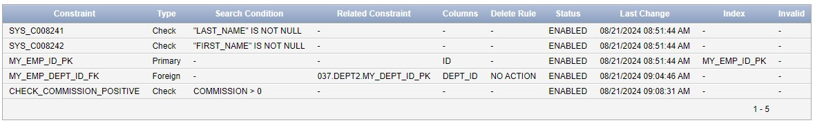 CSE(CYBER SECURITY)-2nd YEAR